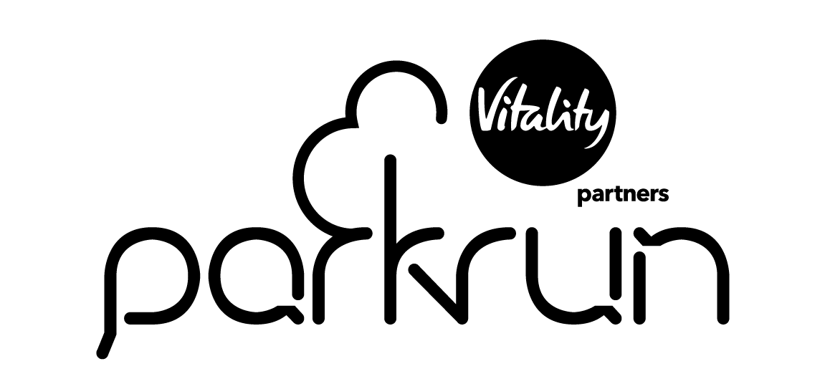
Barking junior parkrun

100th event at Barking Park

Barking junior parkrun are celebrating the 100th event at Barking Park on Sunday 15th June. We invite you to join us for a fun active morning from 8:45am onwards.

We are excited to welcome everyone to celebrate together. We want to make it a real community event so we are inviting other health or sport providers to join us. Either to provide a stall to share information, an activity for young people and their families or to take part in the run or walk.

junior parkrun is a free, fun, friendly, weekly, community event organised by volunteers of all ages for children aged 4 to 14. 2k junior parkrun events take place on Sunday mornings in the UK, Ireland and Australia. It is a great introduction for all the family to be physically active outside together. Walk, jog, run, volunteer or spectate with us.

If you are interested, please contact Steve Camacho on steve.camacho@parkrun.com
